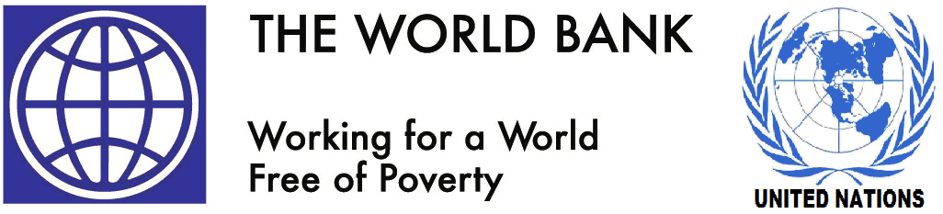
UN/ WORLD BANK COMPENSATION
PAYMENT UNIT
3 WHITEHALL COURT
LONDON, SW1A 2EL.
UNITED KINGDOM

Dear Beneficiary,
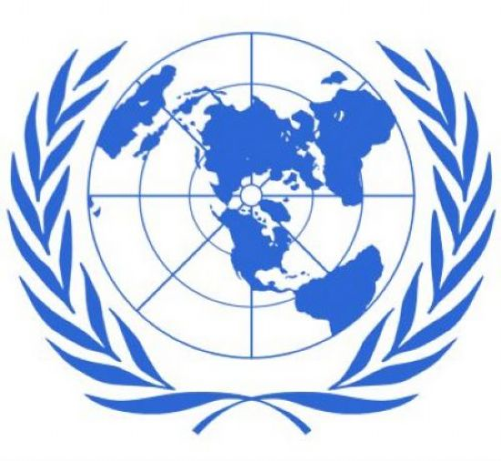
RE: UNITED NATIONS/ WORLD BANK COMPENSATION PAYMENT GBP 950,000.00

The United Nations Compensation Commission in Affiliation with the World Bank is using this medium to compensate all Victims of Natural Disaster and those Lottery winners who have not yet received their winning prizes due to corrupt officials of the lottery payment department. We have received so many complain about the widespread corruption and irregularities within the officials both in Government and Banking sector and within the Lottery organization. So many Lucky winners of the UK National Lottery, Irish Lottery, Coca Cola Lottery, FIFA World cup Lottery, Microsoft/Yahoo Lottery, Common Wealth Lottery, Shell Petroleum Lottery and Euro Million Lotteries have not received their winning prizes up till now.

The United Nation Compensation Commission is receiving a direct support from the World Bank and the United Kingdom government to compensate all Lottery winners who have not yet received their winning prizes due to corrupt officials in the Lottery organization and corrupt delivery agents who were suppose to deliver the winning prizes to the lucky winners. In most cases, these corrupt officials have diverted the lottery prizes into their own personal bank accounts. After the last auditing carried out by the United Nations senior auditors, we discovered that 58 % of lottery winners did not receive their winning prizes. After series of investigations, we discovered that some corrupt officials within the Lottery organization have diverted the lottery prizes into their own personal account.

The United Nations Compensation Commission is using this medium to apologize to all lottery winners who have not received their winning prizes. Your name and e-mail address appeared among the list of lottery winners/beneficiaries who have not yet received their winning prizes. Therefore, we are compensating you with the sum of GBP 950,000.00 Great British Pounds Sterling.

To claim your compensation fund, you have to provide us with your information as stated below:
Your full Name: Home address: Occupation: Age and Sex: Contact Mobile Phone Number:

Forward above information to our E-mail address below: Mr. Michael Wilson

E-mail Address: unworldbnk@hotmail.co.uk
Tel Number: +44-7017431323

Regards,
Mrs. Patricia Williams
Coordinator

