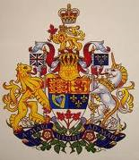
Congratulations! You are £1,000.000.00 richer!
OFFICE OF FOREIGN NOTIFICATION & REMITTANCE
MICROSOFT LOTTERY/ EMAIL DRAW UNITED KINGDOM 49,
Microsoft London (Cardinal Place),
SW1E 5JL London United Kingdom
MICROSOFT LOTT0
EMAIILs:: customerservics@live.co.uk
TEL: + 44 704 578 7764

Winning Numbers: 11/13/17/18/20/45
REF No: UK/9876125
BATCH No: 2011MJL-01
Security Code: MSW/JUL/XX0A7

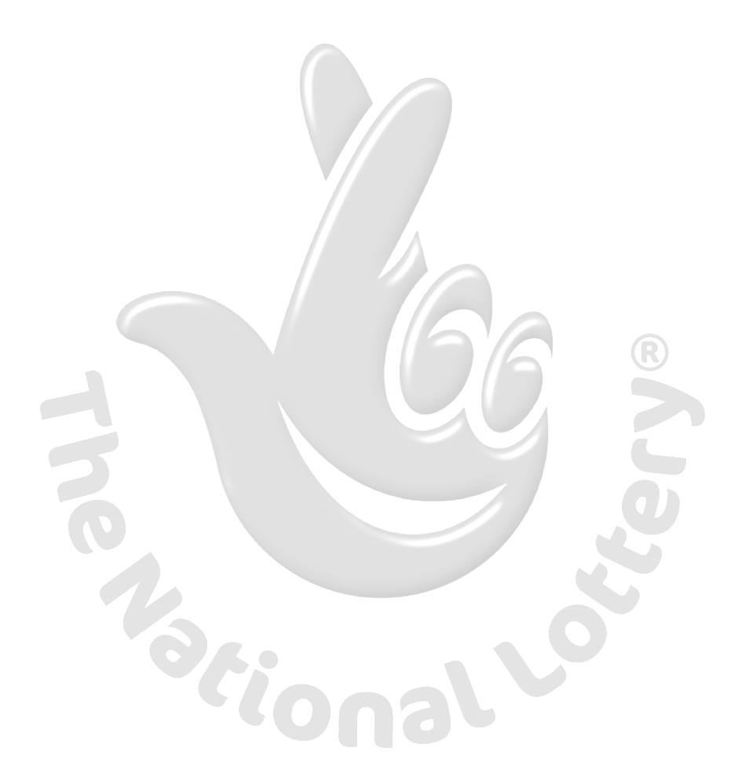
Dear Lucky Winner,

CONGRATULATION! CONGRATULATION!! CONGRATULATION!!!

We happily announce to you the draw result of the Microsoft® International Lottery. The Microsoft® online Sweepstakes International program was held on 13th of July, 2011 and your E-mail address have won £1000.000.00 GBP (One Million Great Britain Pounds Sterlin Only) from Microsoft® lottery draw 2011. This is from a total cash prize shared amongst the other first Ten (10) lucky winners in this category. Your E-mail ID was one of the selected emails all over the world in the lottery draw and it comes out one of the lucky winning numbers.
Please note that your lucky winning number falls within our UNITED KINGDOM booklet representative office in London as indicated in your play coupon, because this particular draw was selected to promote Microsoft NationalLottery.
All participants were selected randomly from World Wide Web site through computer draws system and extracted from over 10,000.00 companies and personal e-mails. To begin your claims therefore, you are advised on final notice and as a matter of urgency, to contact our licensed and accredited Claim agent, for the Processing of your prize awards winning and payment to your designated bank account after all statutory Obligations have been concluded satisfactorily.

You have 5(Five) working days to file for claims from the day of receipt of this email.

To file for your claim, Please Contact your fiduciary agent:
===========================================================
NAME: Mr. Ian Walters
E-MAILS: claimsdept.security@live.co.uk
Phone No.: +44 704 578 7764
===========================================================
You are advised to contact your claims agent with the following details to avoid unnecessary delays and
complications:

1. Your full names………
2. Sex………… Marital Status.............
3. Your address………......
4. Your country………....
5. Nationality…………
6. Your fax……………
7. Home phone number……..........
8. Mobile phone number….........
9. Occupation………………
10. Your age………………

Note: For security reasons and purpose of confidentiality, you are advised to keep your winning information confidential till your claims is processed and your money remitted to you in whatever manner you deem fit to claim your prize. This is part of our precautionary measure is to avoid double claiming and unwarranted abuse of this program and to prevent fraudulent acts. Please be WARNED!!!!

Sincerely,
Mrs. Aileen Barnes
Online Co-coordinator.

