CANADIAN PROMOTIONAL DRAWS COMMISSION
#44, Dine Road, SK, Canada S7N4V8.
Tel/Fax no: + 1 206 338 1411
Dear: Luck winner,

Congratulations your email is among the two lucky winning that (One Million United State Dollars) that drew the winning no: 1 7 23 29 30 33 with a bonus No: 9. In the just concluded draw held to promote 2010 World Cup South Africa, Played in Canada, Sponsored by British American Tobacco Companies South Africa, for urgent release of your fund, please contact our Agent in South Africa immediately.

Therefore you’ve been approved for a total pay out of $1,000,000.00 (One Million United State Dollars) only. With Winning number: 1 7 23 29 30 33 with bonus number: 9

Agents Contacts as follows:
Standard Security Home
Name: Mr. Jonas Randy.
Email: luckywinning@luckymail.com
Telephone: 0027 822 667 848
Agent Alternative Email: Mr.Jonasr@katamail.com
Mon – Friday (8Hrs GMT to 18Hrs GMT) Sat (8Hrs GMT to 12Hrs GMT)

Visit website: http://www2.canada.com/findit/lotteries/results.aspx?id=6
Select View Results for: September 2009 to confirm Sat 19th of September 2009 Winning number: 1 7 23 29 30 33 with bonus number: 9

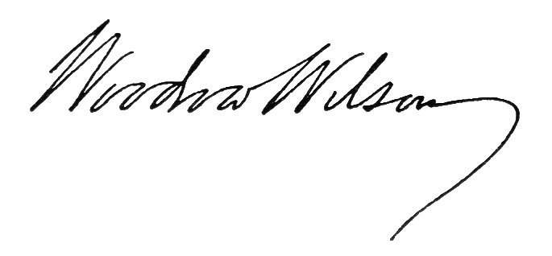
Due to mix up of some numbers and names, we ask that you keep your Winning information confidential until your claim has been processed. This is part of our security protocol to avoid double claims and unwarranted abuse of this program by some participant. Endeavour to include your email address when sending a fax for verification purpose.

Sincerely,
Mrs. Jennifer Loma
Promotions Director
Tel /Fax no: + 1 206 338 1411

